

 | 1 | 2 | 3 | 4
every
everybody
even
great
break
steak
pretty
beautiful
after
fast
Year Two spellings

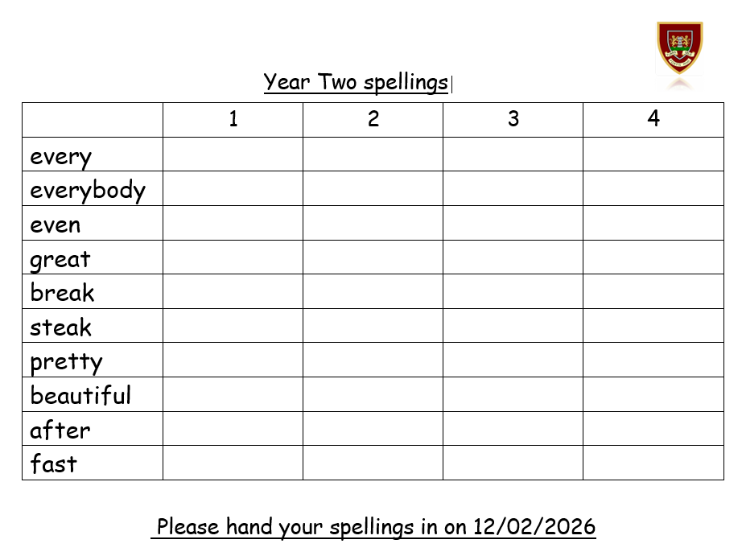
Please hand your spellings in on 12/02/2026

