

 | 1 | 2 | 3 | 4
happier
happiest
angriest
angrier
drier
driest
tidier
tidiest
funnier
funniest
Year Two spellings

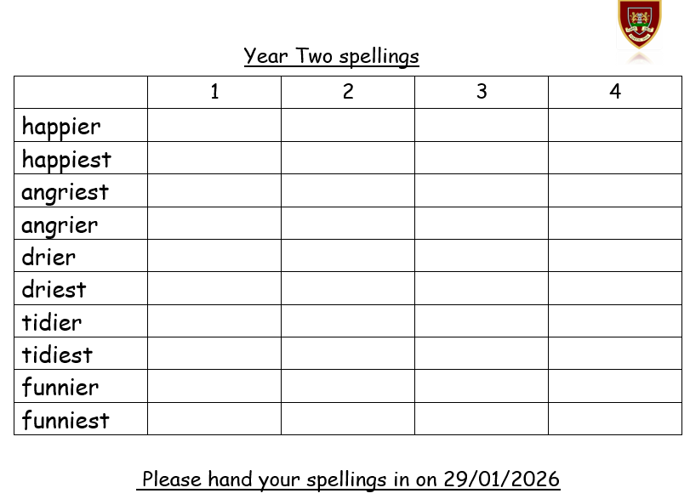
Please hand your spellings in on 29/01/2026

