

 | 1 | 2 | 3 | 4
copied
replied
spied
fried
applied
relied
identified
multiplied
magnified
supplied
Year Two spellings

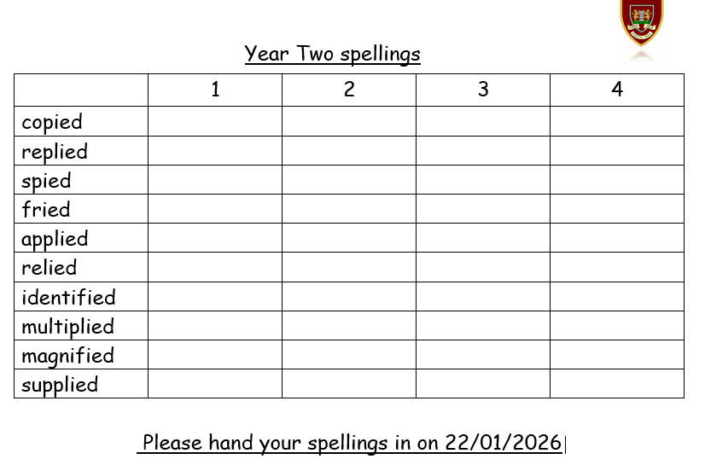
Please hand your spellings in on 22/01/2026

