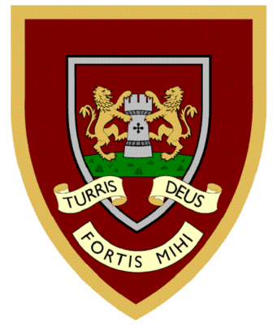

 | 1 | 2 | 3 | 4
flies
tries
replies
cries
copies
babies
carries
spies
supplies
lorries
Year Two spellings

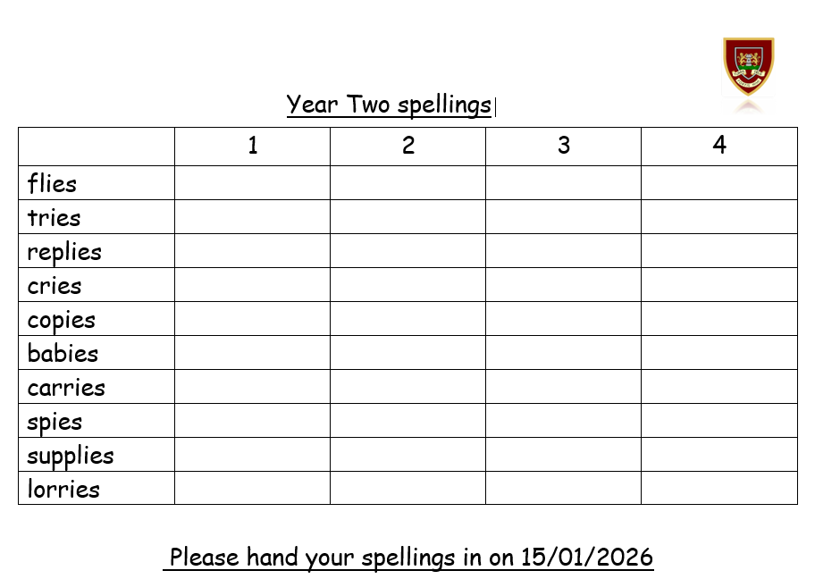
Please hand your spellings in on 15/01/2026

