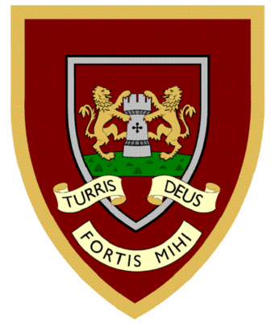

 | 1 | 2 | 3 | 4
cry
fly
dry
try
reply
July
shy
spy
sky
why
Year Two spellings

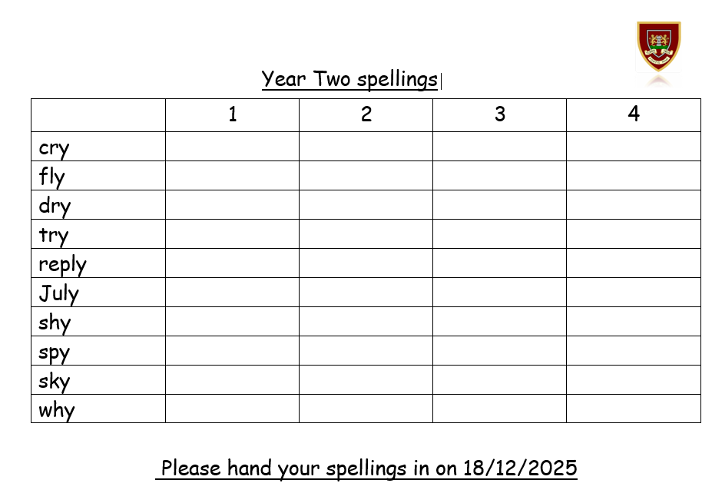
Please hand your spellings in on 18/12/2025

