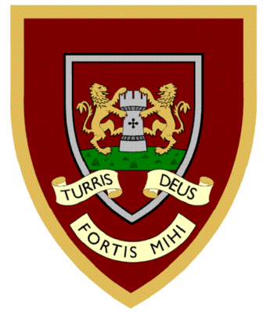

 | 1 | 2 | 3 | 4
wild
climb
most
only
both
old
cold
gold
hold
told
Year Two spellings

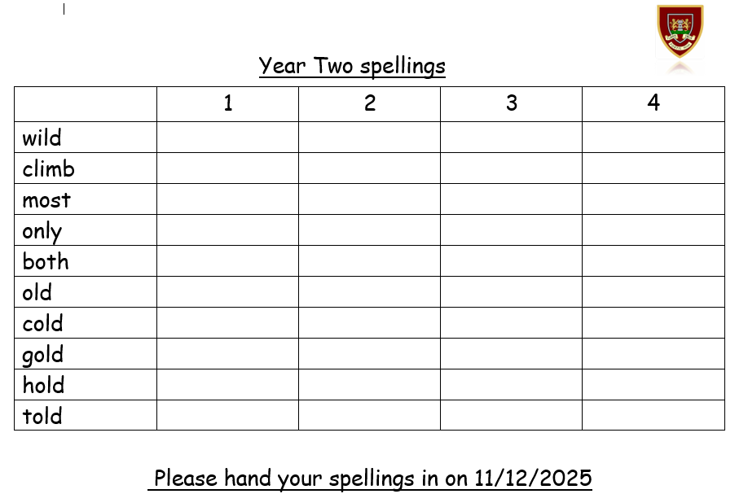
Please hand your spellings in on 11/12/2025

