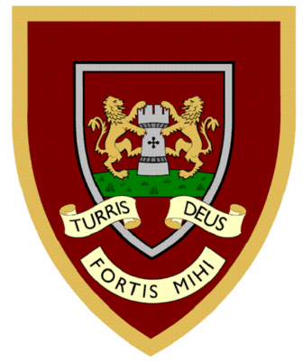

 | 1 | 2 | 3 | 4
pencil
fossil
nostril
pupil
April
gerbil
lentil
evil
anvil
basil
Year Two spellings

Please hand your spellings in on 04/12/2025


