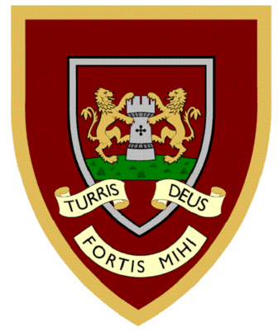

 | 1 | 2 | 3 | 4
medal
petal
capital
hospital
animal
equal
final
pedal
local
magical
Year Two spellings

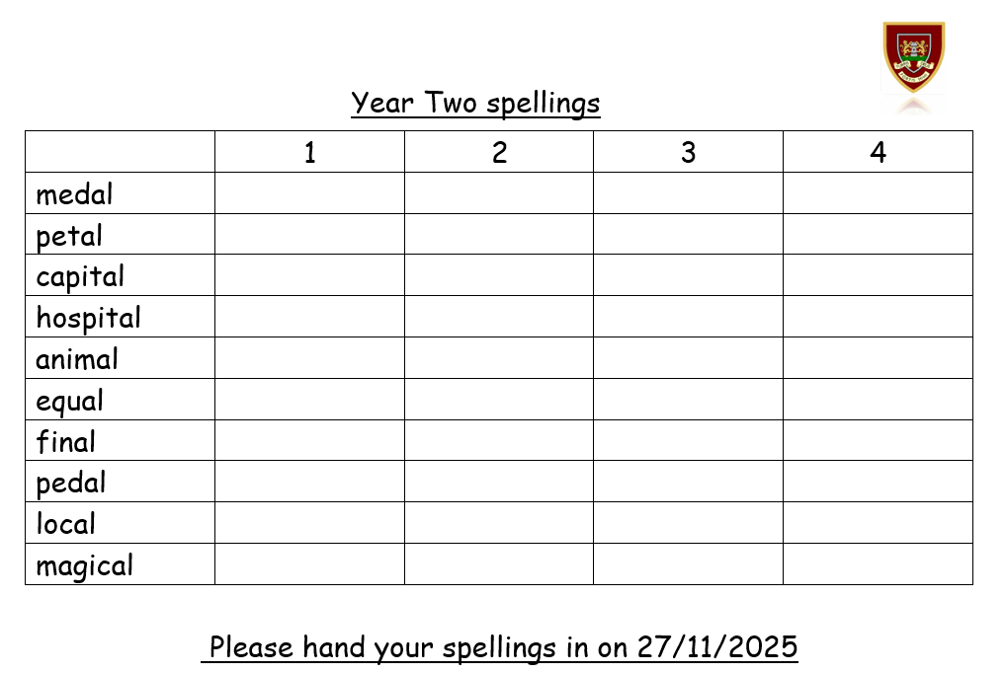
Please hand your spellings in on 27/11/2025

