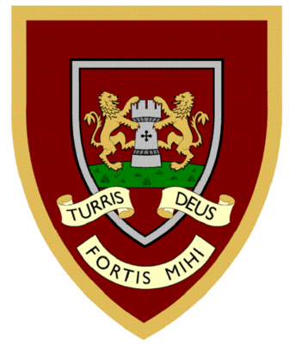

 | 1 | 2 | 3 | 4
camel
tunnel
squirrel
travel
towel
tinsel
hazel
vowel
angel
jewel
Year Two spellings

Please hand your spellings in on 20 /11/2025


