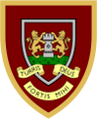
Use the ‘Book-Talk’ questions in this guide to prompt discussion between you and your child as you share a story, poem or non-fiction text.
Reading at Home ‘Book-Talk’ Questions
A Guide for Parents

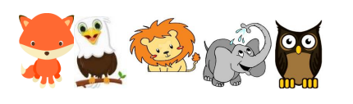

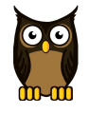
The wise owl helps us to make sure we know the meanings of words.
Draw on knowledge of vocabulary to understand texts.

Which word tells you about how big/small…?

Which word tells you that…?

Find words/phrases that you tell you about __________ (character/setting)

What do the words _______ tell you about the _______?

Find and copy one word that tells you….

Find and copy one word that means the same as ______

What does the word _____ mean?

What does it mean in this sentence?

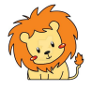
The lion helps us hunt for important information in the text.
Identify and explain key aspects of fiction and non-fiction texts, such as characters, events, titles and information.

How would you describe this story/text?

How do you know?

What would be another good title for the story/poem/recount/text?

How did…? How often…? Who had…? Who is/was…?

What happened to______? What does/could …? What did…? What was…?

What had…? What are…? What is another name for…? What might…?

Where did…? Why did…? When were…? Why can…?

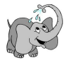
The elephant who never forgets, helps us to remember the sequence of events.
Identify and explain the sequence of events in texts.

What happened after…?

What was _____ doing when…?

What did ______ do after ______ did …?

Put the sentences in the order that the events happened.

Draw a timeline of the events. When does ______ happen?

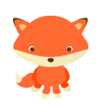
The sly fox helps us to infer from the text.
Make inferences from the text. (The fox needs to be really clever because the answer is not always in the text.

How did (character) feel when …?

What does ______tell you about (character)?

Explain how ______ felt about…? How do you know?

Why do you think ______felt ______? What makes you think that?

Why did ______say/do/think ______? What makes you think that?

Why was ______ sad/happy/excited/…?

What did ______ mean when she/he said…?

What is fact/opinion? How do you know?

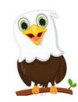
The hawk’s eyes see into the distance and help us to predict what might happen.
Predict what might happen on the basis of what has been read so far

What do you think this story is going to be about? What makes you think that?

Where do you think this poem/story is set? What makes you think that?

What is happening now? What do you think might have happened before?

Based on what you have read, what does the last paragraph suggest might happen next?

What has happened? What is happening now? What do you think might happen next?

