

 | 1 | 2 | 3 | 4
write
written
wrong
wrap
wren
wrecked
wrapped
wriggle
wrestle
wrote
Year Two spellings

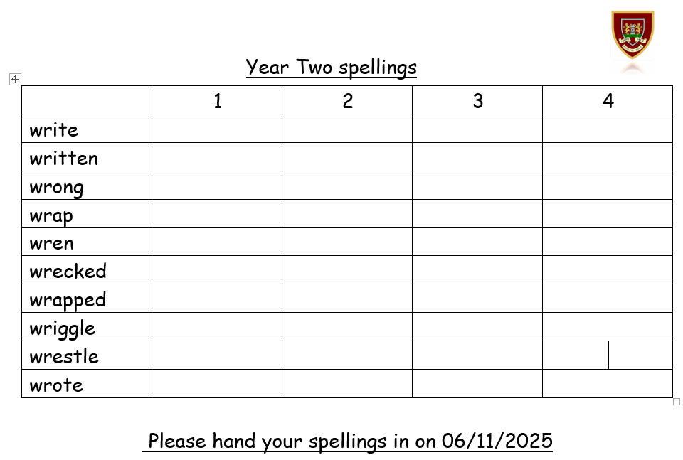
Please hand your spellings in on 06/11/2025

