

 | 1 | 2 | 3 | 4
door
floor
poor
because
find
kind
mind
behind
child
children
Year Two spellings

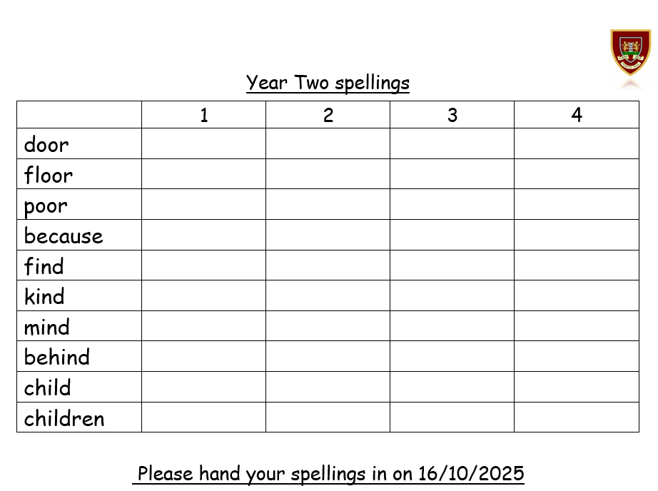
Please hand your spellings in on 16/10/2025

