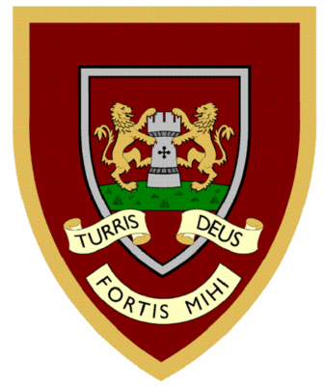

 | 1 | 2 | 3 | 4
knock
know
knee
knit
knew
knight
gnome
kneel
gnat
gnaw
Year Two spellings

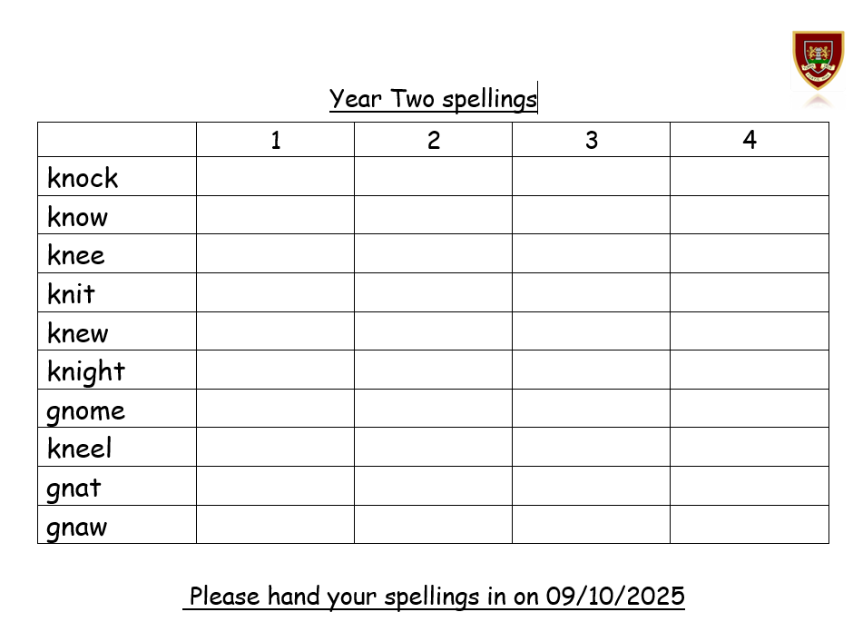
Please hand your spellings in on 09/10/2025

