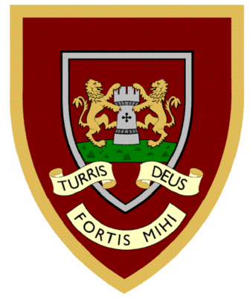

 | 1 | 2 | 3 | 4
race
ice
cell
city
fancy
lace
space
circle
circus
rice
Year Two spellings

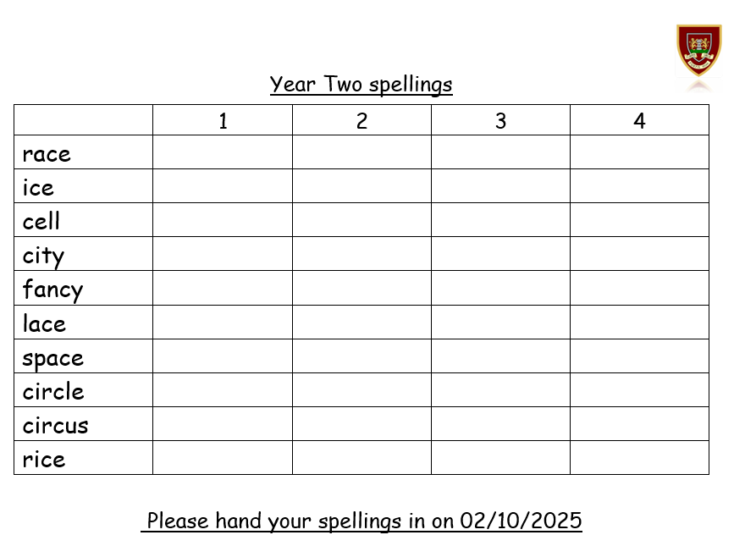
Please hand your spellings in on 02/10/2025

