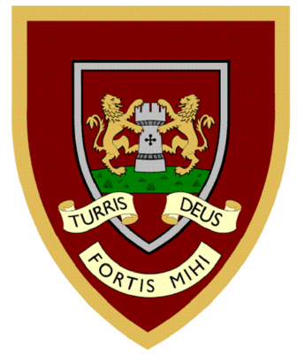

 | 1 | 2 | 3 | 4
gem
gym
giant
magic
giraffe
energy
digit
engine
religion
gentle
Year Two spellings

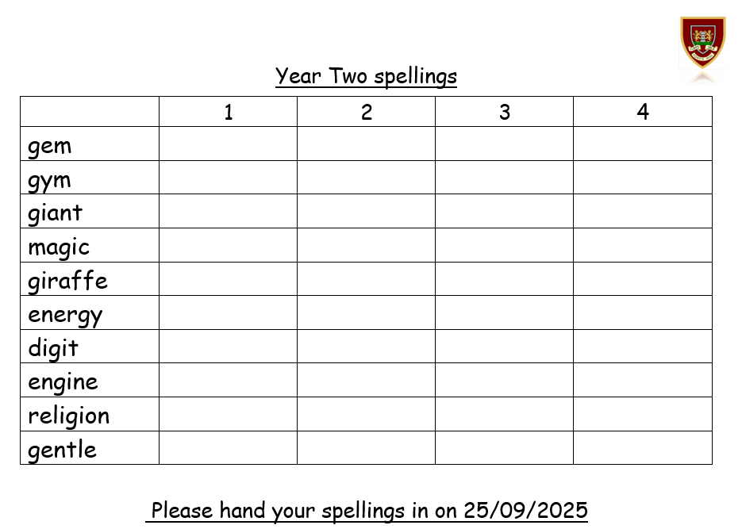
Please hand your spellings in on 25/09/2025

