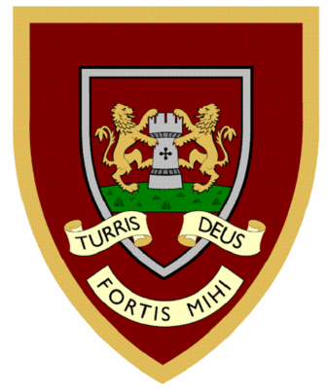
Year Two spellings
Look, cover, write
 | 1 | 2 | 3 | 4
badge
edge
bridge
dodge
fudge
ridge
smudge
judge
wedge
lodge


